PAPER TITLE (14 pt, bold, capitals, center)
(14pt)
First name LAST NAME(14pt, italics, center)
Institution (14pt, center)
E-mail: prenume_nmbn@fgn.com (14pt, center)
(12pt)
ABSTRACT (12pt, bold, capitals, left)
The abstract includes the paper’s objectives and contributions to the research theme, the nature and significance of the research theme, the adequacy of the methodology, results and conclusions. The abstract is refered to/ written in the third person, plural form. (12pt, italics, justified)

KEY WORDS (10pt, bold, capitals, left)
4 to 6 key words, relevant for the paper’s content (12pt, italic, left)

JEL CLASSIFICATION (12pt, bold, capitals, left)
A JEL classification code is chosen (12pt, italic, left)
(12pt)

INTRODUCTION (12pt, bold, capitals, left)
The importance of the theme, the purpose and the contribution of the paper are enounced, along with a brief explanation of the employed approach, the most important conclusions and the structure of the paper.
The relevance and the importance of the research conducted, by generally presenting the domain and the state of the authors’s own research in the context; the purpose (objectives, research questions or hypothesis) and the contribution of the paper; the approach used and the paper’s structure are presented.
The recommended paper size is between 5 and 20 pages, written in accordance to the present instructions, both in English and Romanian. (12pt)
(12pt)
1. TITLE (12pt, bold, capitals, left)
In the body of the paper the literature review, the research methodology, the research results and conclusions are presented. The paper should have a logical and clear structure, implemented by means of titles and subtitles. The authors are encouraged to include a description of the research importance for auditors.
(12pt)
1.1. Subtitle (12pt, bold, left)
For paper editing the following format should be used:
- Paper size A4 (297x210)
- Margins: top 2 cm, down 2 cm, inside 2 cm, outside 2 cm, mirror margins, header 1,27 cm, footer 1,27 cm
- Font: Times New Roman, size 12, line spacing: single, justified aligned.
- The paper is edited as a single column, continuous, no free spaces, except the blank lines between chapter titles and text, between paragraphs or between the body text, figures or tables.
Chapter titles should be numbered continuously, and the number of subtitle levels should not exceed 3 (for example, 1.2.1.), their use and number being the author's choice.
References will be quoted using the Harvard style. Here are some examples for the most common situations:
- the quoted paper has a single author: “The role of the external independent assurance for integrate reporting and the difficulty to choose appropriate standards was also signaled by Oprișor (2015).”
- two – four authors: “Credibility is a means to improve the interest for non-financial information (Eccles, Krzus and Watson, 2012).”
- more than four authors: “Long term sustainability and the development of these economies depends on the existence and the success of the private enterprises and their management (Lukman et al., 2011)”.
Figures, charts, tables will be aligned in the center, numbered in the order in which they are presented and formatted as black and white. The source (if any) will be placed under the figure, table or chart. The font for the tables should be the same as the one used for body text. In the case of extremely large tables, a whole page will be used (including table title, source and legend, if necessary) as well as an adequate orientation of the table. The „Heading rows repeat” option in the “Table” menu may be used, if the table does not fit on a single page.
(12pt)
Table 1. Table name (12 pt)
NC | Continent | Percent
1 | Europe | 33,33%
2 | America | 31,81%
3 | Africa | 33,33%
4 | Asia and Australia | 41,18%

(Source: Author, 2016) (12pt) or (Source: Author’s compilation, 2016) (12pt)
(12pt)
For figures and charts, the number and the name are specified below the figure, after the statement of the source.
(12pt)
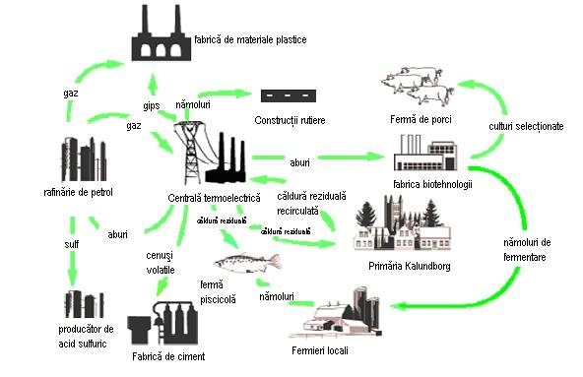
(Source: Author, 2016) (12pt) or (Source: Author’s compilation, 2016) (12pt)
Figure 1. Figure name (12pt)
(12 pt)
CONCLUSIONS (12pt, bold, capitals, left)
The conclusions synthesize the research results and discuss their significance from a theoretical and practical point of view. The research limitations and the future research directions are also specified. (12pt)
(12pt)
ACKNOWLEDGEMENTS (12pt, bold, capitals, left)
(12pt)
REFERENCES (12pt, bold, capitals, left)
The references section only includes the sources quoted in the text.
References are ordered alphabetically, based on the last name of the first author.
Font: Times New Roman, 12; Paragraph: Justified, Hanging 0,5 cm.

Editing style: Harvard

Examples:
Articles in journals:
Oprișor, T. (2015), Contributions to an improved framework for integrated reporting, Accounting and Management Information Systems, vol. 14, no. 3, pp. 483-507.
Books:
Dragomir Voicu, D. (2012a), Sustainability reporting: a case for corporate accountability, Bucureşti, Editura ASE.
Articles in conference proceedings volumes
Eccles, R.G., Krzus, M.P. and Watson, L.A. (2012), Integrated Reporting Requires Integrated Assurance. In Effective Auditing for Corporates: Key Developments in Practice and Procedures, edited by Joe Oringel, 161–178. London: Bloomsbury Information Ltd.

